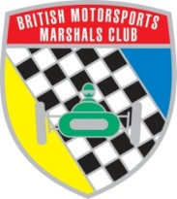 | BRITISH MOTORSPORTS MARSHALS’ CLUB LTD.  Role Description National Secretary 2021

The Club Secretary is responsible for :-
- Arrange and attend Council meetings, usually 4 per annum and currently held at any suitable venue. From 2021 these will also include virtual meetings held in Zoom format online, until such time as the situation changes.
- Arrange and attend AGM usually first Sunday of December. Held in conjunction with the final Council meeting of the year at a suitable venue. Again this could be a virtual meeting held in Zoom format.
- Prepare Agenda, take minutes of each Council meeting and AGM. Deputising for Chairman as and when required.
- Prepare the Club’s Annual Report within a strict timetable for publication on the Club’s website.
- Administering Club Rules and presenting recommendations for changes as and when appropriate.
- Maintaining BMMC records including MSA Club Membership, Companies House records, GDPR Compliance records.
- To establish and refine Council / Committee documentation with regard to formalising / standardising such documents for ease of use.
- Dealing with general Club correspondence and communications.
- Attending meetings from time to time with other National Officers (Chairman and Treasurer), representatives of Council and regional committees and other motor sport organisations.
- To represent, and attend meetings where practicable, the Club’s position on Regional Associations.

P Wiltshire
( National Secretary )

